AI-DRIVEN COMPLEX EMOTION RECOGNITION USING FACIAL EXPRESSION IMAGES
Design and Implementation
Department of Computer Science and Engineering (Data Science), [COLLEGE NAME]
Batch A16 (CSDS-A) · Academic year [ACADEMIC YEAR]
Table 1: Project team
S.No. | Student name | Roll number
1 | B. Shirisha | 23K91A6730
2 | B. Ashrith | 23K91A6731
3 | B. Murali | 23K91A6724
4 | B. Goutham | 23K91A6727

Project guide: [GUIDE NAME]
Chapter and section numbers quoted in the text (for example Chapter 8 or Section 6.2) refer to the full project report, 17.Final Document. Figures and tables in this document are numbered from 1.

1. DESIGN
This chapter describes how Mosaic is built: the architecture and workflow, the data flow, the class, sequence and use-case design, the data design, the core algorithms, the module and API design and the user interface. Every diagram was drawn from the code in backend/app (main.py, routers/, ml/, models.py, security.py) and frontend/src; the complete set, each with a longer explanation, is also collected in the Block Diagrams document.
Three facts about the design are stated at the outset because they shape everything below. Mosaic is a single Python process with a browser front end: there is no queue, no worker and no external service, and the network, the face detector and the SQLite file are all used inside the request that needs them. Its recognition is multi-label: the final network has 18 independent sigmoid outputs (seven basic and eleven compound), so one face can carry several positive labels, and the rule that picks the single dominant emotion is just an argmax over those 18. And its compound half is trained on synthetic faces only, because the real dataset has no compound labels. The design follows the two-stage analysis-by-synthesis scheme of the base paper [1] (generate, then recognise) at a much smaller scale and omits its identity-preserving encoder.

1.1 Design Goals and Architecture
Five goals shaped the design. First, one model for basic and compound emotions, so that the service stays a single forward pass. Second, make the generator's contribution testable: the final network is initialised from a separately trained 7-class backbone, so that the effect of the synthetic faces can be compared with a no-synthesis control. Third, be private by default: uploaded photographs are never written to disk, only the cropped grayscale face of a signed-in user is kept, and a user can delete it. Fourth, run on a laptop without special hardware: everything is CPU-only PyTorch. Fifth, keep the API contract small and stable, so that the front end and back end could be built independently from API_CONTRACT.md.
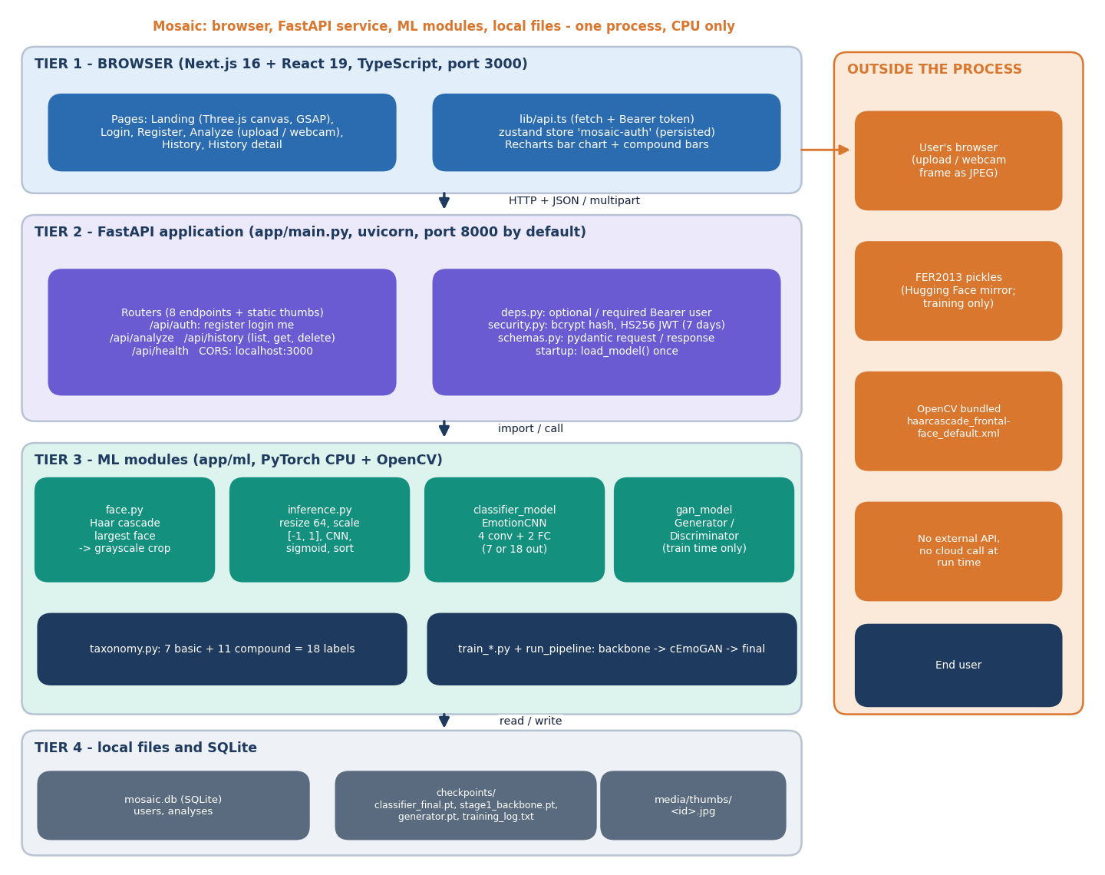
Figure 1: System architecture of Mosaic: browser tier, FastAPI service, ML modules and local files.
The architecture has four tiers. The browser tier is a Next.js 16 application (React 19, TypeScript) served on port 3000; it keeps the session token in a persisted zustand store named mosaic-auth and calls the API with fetch. The FastAPI application (uvicorn) listens on port 8000 by default (port 8116 during this documentation run, because another program held 8000) and mounts the thumbnail folder as static files under /api/media/thumbs. CORS admits only http://localhost:3000 and http://127.0.0.1:3000. The ML tier is a set of plain Python modules: face.py (Haar detector), inference.py (preprocessing, forward pass, ranking), classifier_model.py (the CNN), gan_model.py and the training scripts. State lives in mosaic.db, in the three checkpoint files under checkpoints/, and in media/thumbs/. At start-up main.py creates the tables and tries to load classifier_final.pt; if the file is absent the server still starts and /api/health reports model_loaded: false.

1.2 High-Level Workflow
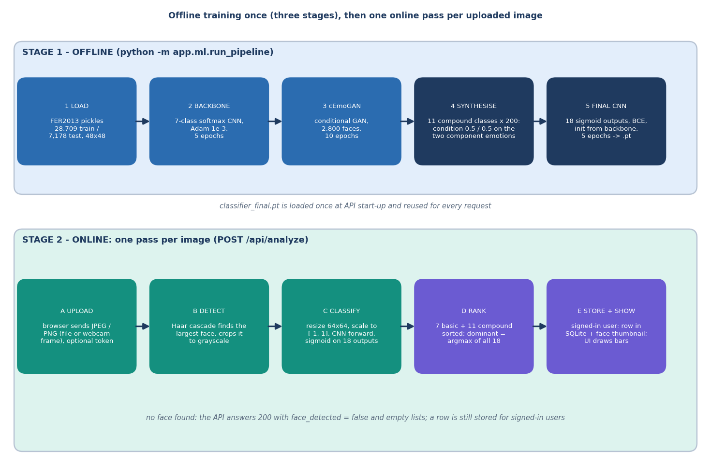
Figure 2: High-level workflow: three offline training stages, then one online pass per uploaded image.
The workflow has two time scales. Training is a command-line program, python -m app.ml.run_pipeline, which runs three stages in order and appends one line per stage to checkpoints/training_log.txt: the 7-class backbone (five epochs), the conditional GAN (ten epochs on 2,800 faces) and the final 18-output classifier (five epochs on 28,709 real and 2,200 synthetic faces). Serving is a request-driven path: each upload is decoded, a face is located, the face is classified and the answer is returned and, for a signed-in user, stored. There is no batching and no queue; the measured median for the whole path is about 19 ms on the development machine.

1.3 Data Flow Diagrams

1.3.1 Level 0: context
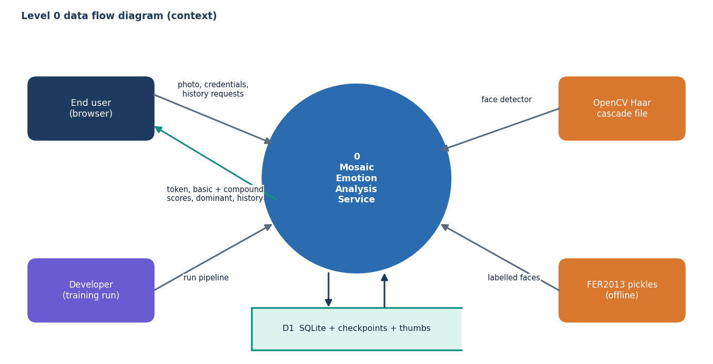
Figure 3: Level 0 data flow diagram: Mosaic and its four external entities.
At level 0 the system has four neighbours. The end user supplies photographs and credentials and receives tokens, scores and history; the developer starts the training pipeline; the OpenCV package supplies the Haar cascade file; the FER2013 pickles supply labelled faces at training time only. A single store, D1, stands for the SQLite database, the checkpoints and the thumbnail folder.

1.3.2 Level 1: seven processes
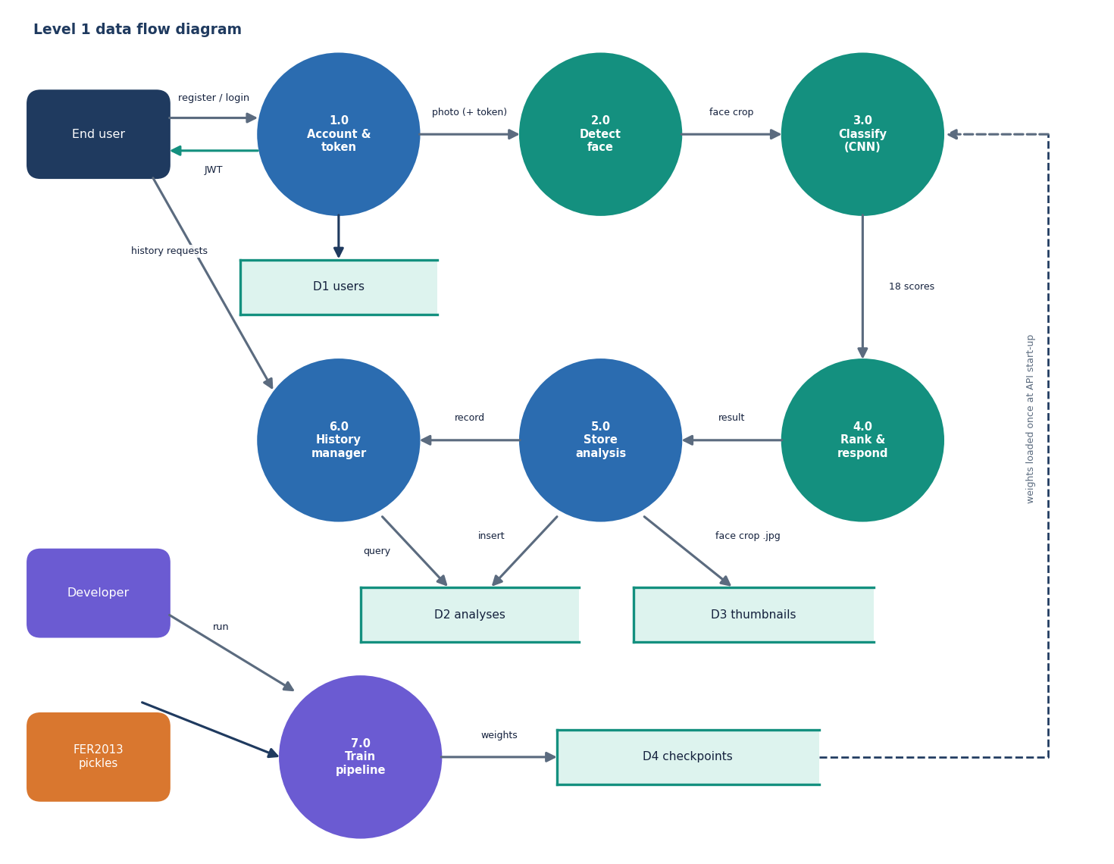
Figure 4: Level 1 data flow diagram: seven processes and four data stores.
Level 1 separates seven processes. Process 1.0 handles registration and login against the users store D1. Processes 2.0 (face detection), 3.0 (classification) and 4.0 (ranking and response) run once per upload. Process 5.0 stores the analysis row in D2 and the face thumbnail in D3, and 6.0 lists, reads and deletes history rows. Process 7.0, the offline training pipeline, produces the checkpoint files of D4 from the FER2013 pickles; process 3.0 loads them once when the server starts. Process 5.0 runs for every signed-in call, including calls where no face was found (the row then has empty emotion lists and no thumbnail).

1.3.3 Level 2: classification and ranking
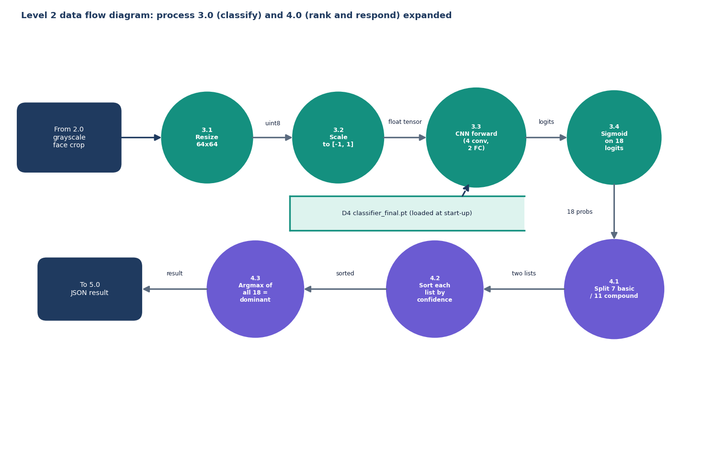
Figure 5: Level 2 data flow diagram: processes 3.0 (classify) and 4.0 (rank and respond) expanded.
Process 3.0 is expanded into resizing the crop to 64 x 64 pixels, scaling intensities to the range minus one to one (x/255, then (x - 0.5)/0.5), the forward pass through the four convolutional blocks and two fully connected layers, and a sigmoid on the 18 logits. Process 4.0 splits the 18 probabilities into the seven basic and eleven compound scores, sorts each list by confidence in descending order, and takes the index of the largest of all 18 as the dominant emotion, labelled basic if the index is below seven and compound otherwise.

1.4 UML Class Design
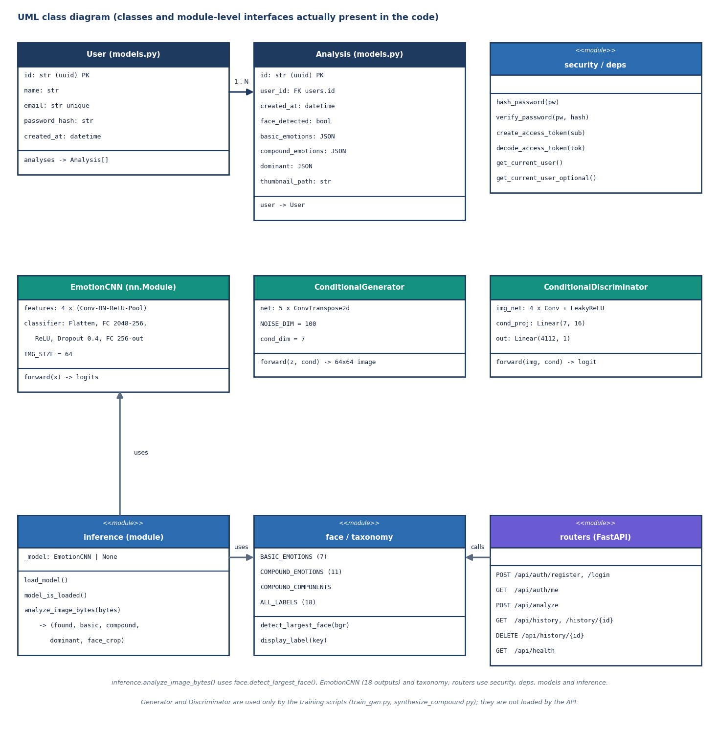
Figure 6: UML class diagram of the classes and module-level interfaces present in the code.
The class diagram contains only what exists in the code. User and Analysis are SQLAlchemy models joined by a one-to-many relationship with cascading delete. EmotionCNN is one class used with two output sizes: seven for the backbone and 18 for the final model. ConditionalGenerator (1,128,353 parameters) maps 100 noise values plus a seven-element condition to a 64 x 64 image through five transposed convolutions and a tanh; ConditionalDiscriminator scores an image together with its condition. The remaining boxes are function modules (security, dependencies, inference, face detection plus taxonomy, routers) drawn with the stereotype <<module>>. The generator and discriminator are used only by the training scripts.
Table 2: The EmotionCNN layers (ml/classifier_model.py)
Stage | Layers | Output shape
Input | 1-channel 64 x 64 face, scaled to [-1, 1] | 1 x 64 x 64
Block 1 | Conv 3x3 (32), BatchNorm, ReLU, MaxPool 2 | 32 x 32 x 32
Block 2 | Conv 3x3 (64), BatchNorm, ReLU, MaxPool 2 | 64 x 16 x 16
Block 3 | Conv 3x3 (128), BatchNorm, ReLU, MaxPool 2 | 128 x 8 x 8
Block 4 | Conv 3x3 (128), BatchNorm, ReLU, MaxPool 2 | 128 x 4 x 4
Classifier | Flatten (2,048), Linear 256, ReLU, Dropout 0.4, Linear out_dim | 7 (backbone) or 18 (final); 770,130 parameters at 18

The architecture combines standard components: batch normalisation [25], dropout [26] and, for the final model, sigmoid outputs with binary cross-entropy, the usual formulation of multi-label learning [27]. It is deliberately close to the 'simple CNN' of the base paper, which also ends in a sigmoid layer, but it is a different, smaller network trained on different data.

1.5 Sequence Design of the Main Flow
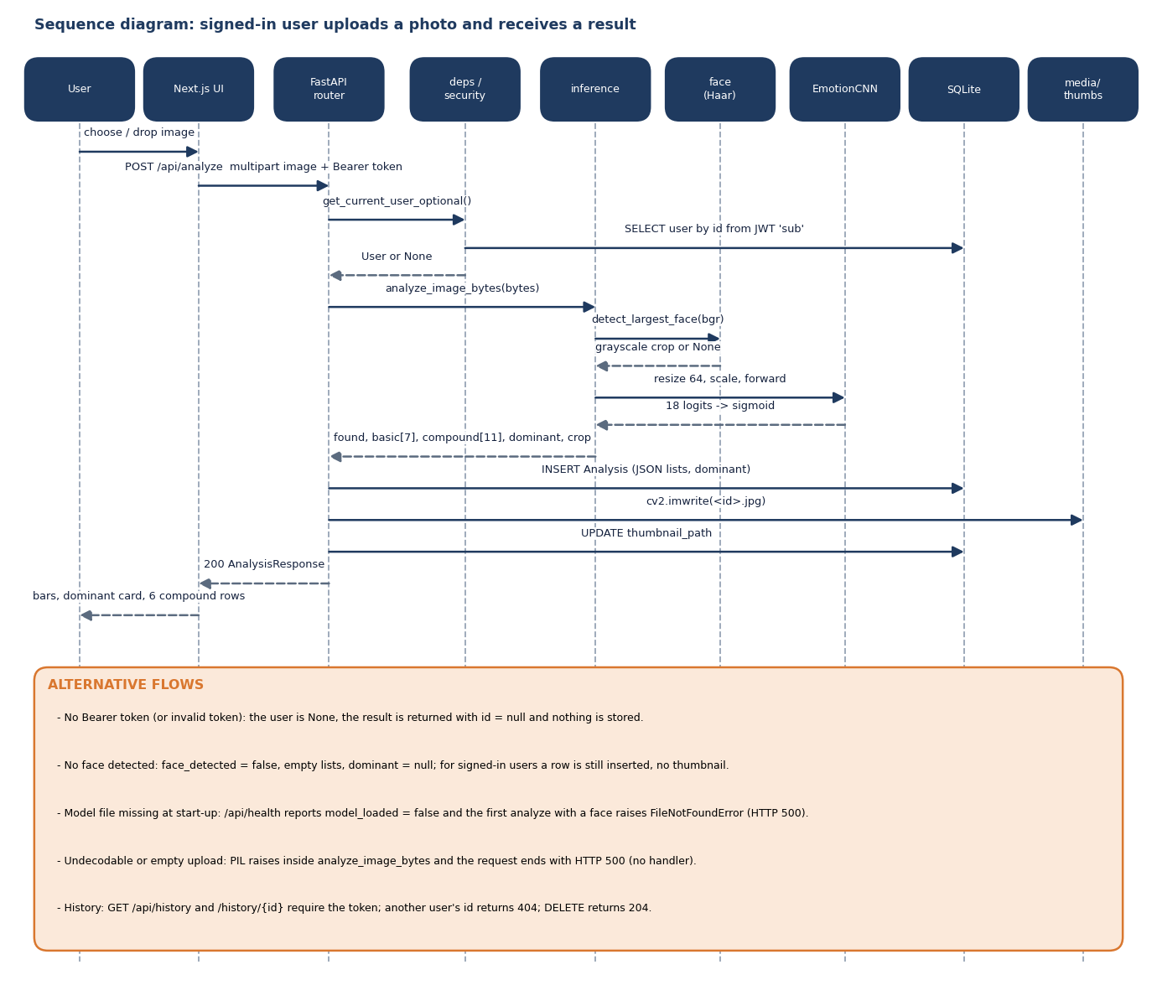
Figure 7: Sequence diagram: a signed-in user uploads a photo and receives a result.
The main flow is the analysis of one photo by a signed-in user. The router asks deps.get_current_user_optional() for the user: if the Bearer token is absent or invalid the user is None and the flow continues anonymously. analyze_image_bytes() then runs the detector and the network and returns the lists. For a signed-in user the router inserts an Analysis row, commits, writes the cropped face to media/thumbs/<id>.jpg and updates thumbnail_path, so a successful analysis costs two commits. The alternative flows at the foot of the diagram record behaviour that was verified by the tests: anonymous calls are not stored, images without a face give face_detected: false, and another user's history id gives 404.

1.6 Use-Case Design
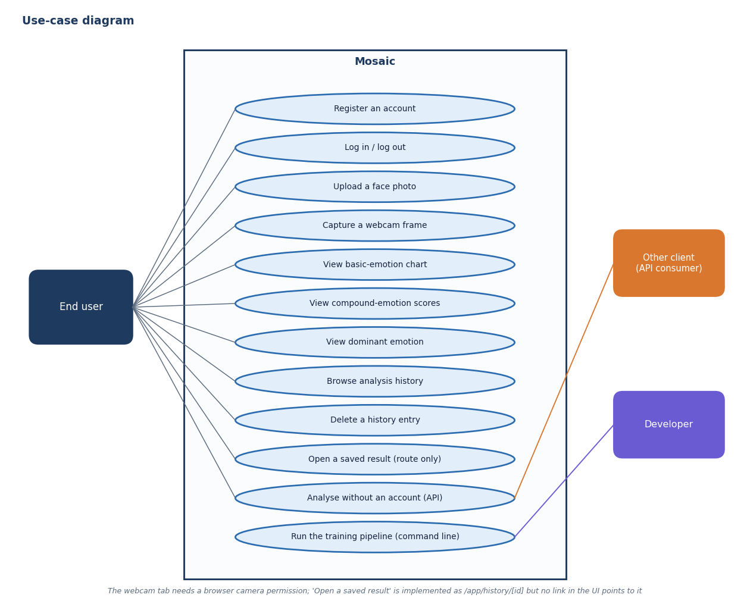
Figure 8: Use-case diagram: what the end user, an API client and the developer can do.
The end user's use cases are registration, login and logout, analysing a photo (upload or webcam), reading the three views of the result, browsing the history and deleting an entry. An opened history entry has its own route, /app/history/[id], but no element in the history page links to it; the route can be reached only by typing the address. Other API clients can analyse without an account, in which case nothing is stored. The developer's single use case is running the training pipeline. No use case needs an administrator, which is why the design has no such role.

1.7 Database Design
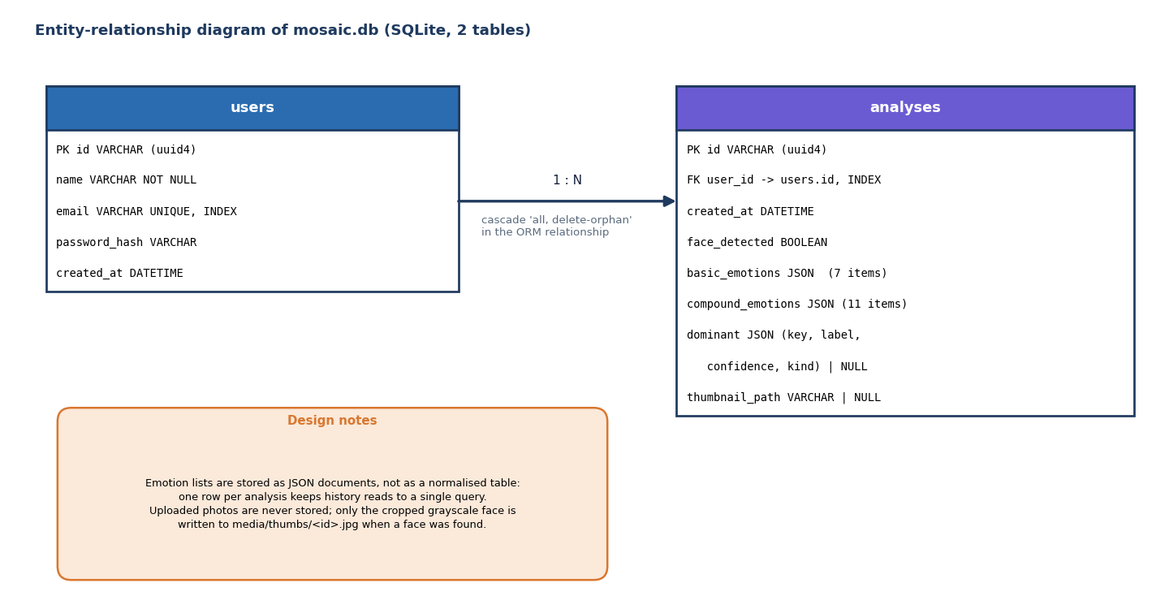
Figure 9: Entity-relationship diagram of the SQLite database: two tables joined one-to-many.
The database has two tables. User identifiers and analysis identifiers are random UUID strings. The 18 scores of an analysis are not spread across 18 columns: basic_emotions, compound_emotions and dominant are JSON columns holding the same objects the API returns (key, label, confidence, and kind for the dominant emotion). This keeps a history read to one query and lets the label set change without a migration, at the price that scores cannot be filtered or aggregated in SQL. The only declared foreign key is analyses.user_id.
Table 3: Table users
Column | Type | Constraint | Meaning
id | VARCHAR | Primary key (uuid4) | User identifier, also the JWT sub claim
name | VARCHAR | NOT NULL | Display name
email | VARCHAR | UNIQUE, INDEX, NOT NULL | Login name; format is not validated (any string is accepted)
password_hash | VARCHAR | NOT NULL | bcrypt hash through passlib
created_at | DATETIME | default UTC now | Registration time

Table 4: Table analyses
Column | Type | Constraint | Meaning
id | VARCHAR | Primary key (uuid4) | Analysis identifier, also the thumbnail file name
user_id | VARCHAR | FOREIGN KEY users.id, INDEX, NOT NULL | Owner
created_at | DATETIME | default UTC now | Time of analysis
face_detected | BOOLEAN | default false | Whether the Haar detector found a face
basic_emotions | JSON | default [] | Seven objects {key, label, confidence}, sorted by confidence
compound_emotions | JSON | default [] | Eleven objects, sorted by confidence
dominant | JSON | nullable | {key, label, confidence, kind} for the argmax of all 18; null when no face
thumbnail_path | VARCHAR | nullable | Path of the cropped grayscale face under media/thumbs/

1.8 Core Algorithms

1.8.1 Inference: analyze_image_bytes()
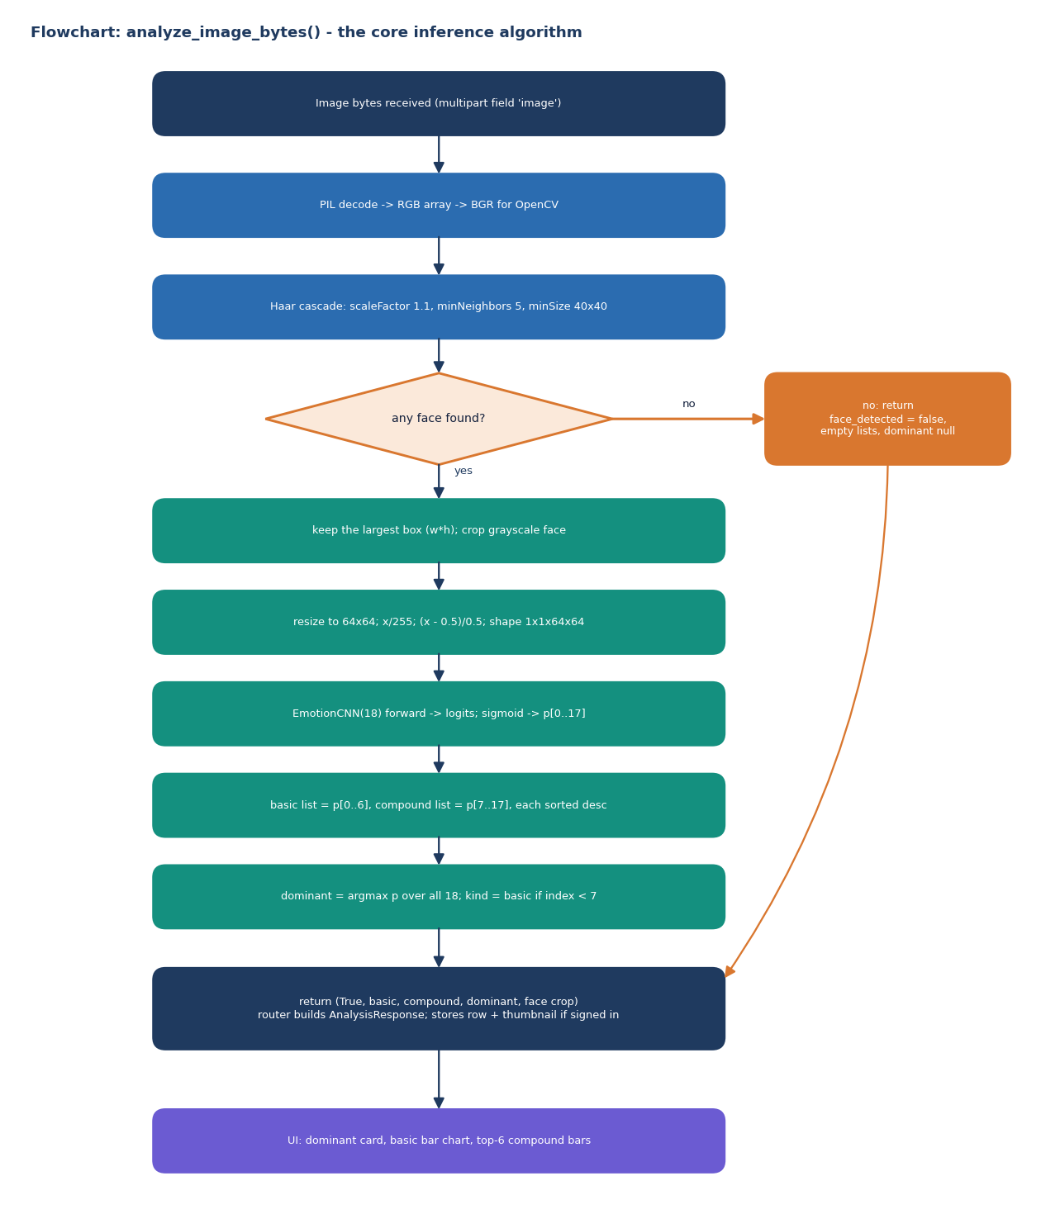
Figure 10: Flowchart of analyze_image_bytes(), the algorithm every request passes through.
The decoding step uses Pillow and converts to RGB, then to BGR for OpenCV. The Haar cascade haarcascade_frontalface_default.xml is run on the grayscale image with scale factor 1.1, five minimum neighbours and a minimum face size of 40 x 40 pixels [23]; the face with the largest width times height is kept. The crop is resized to 64 x 64, scaled, passed through the network and a sigmoid. The function has a threshold argument that is never used; the decision rule is simply the argmax. This rule has an important consequence: because a compound output must exceed every basic output to be chosen, and the compound outputs are tiny after training (Chapter 8), the dominant emotion is in practice always basic.

1.8.2 Training: three stages
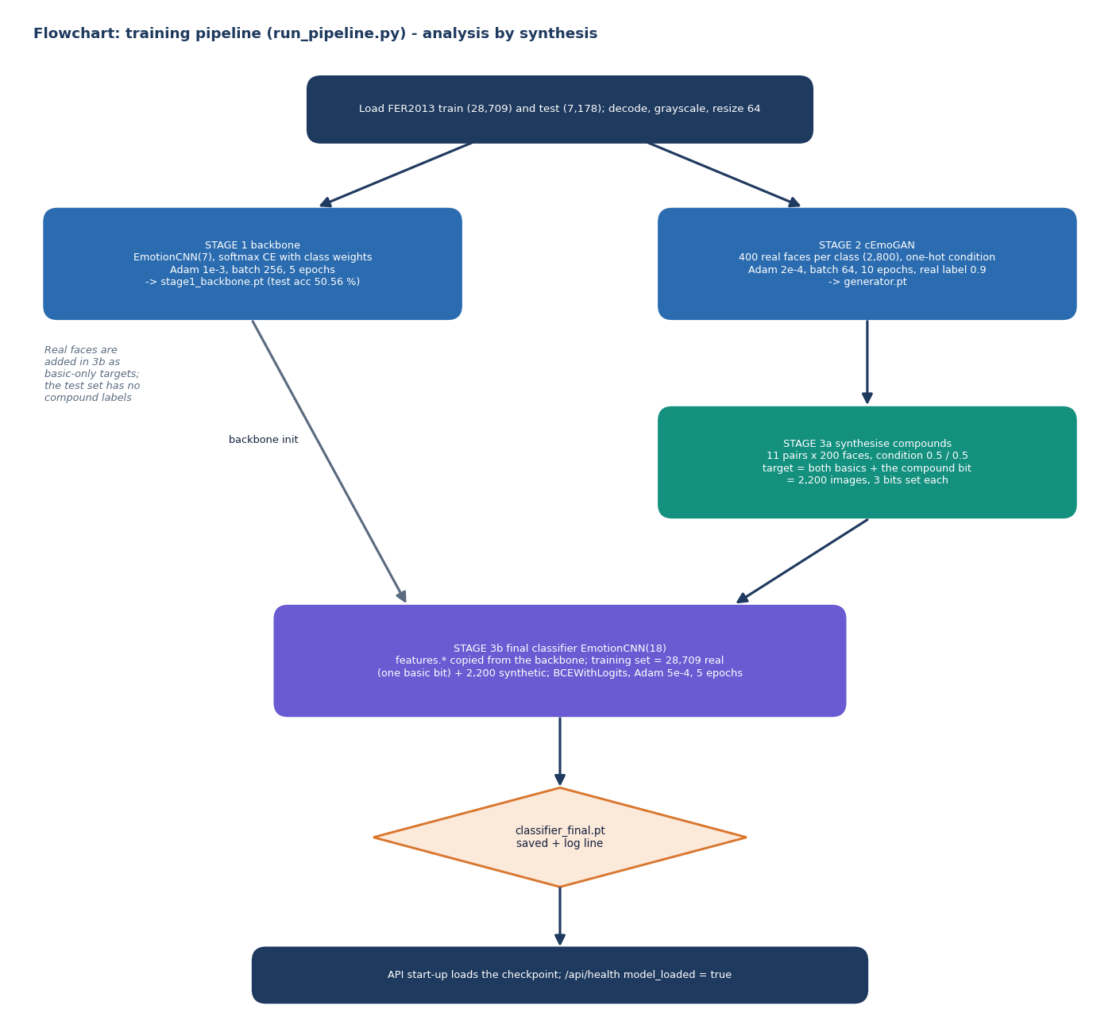
Figure 11: Flowchart of the training pipeline: backbone, cEmoGAN, synthesis and the final multi-label classifier.
Stage 1 trains the backbone with class-weighted cross-entropy and Adam [24] at a learning rate of 1e-3. Stage 2 trains the conditional GAN [17][16] with Adam at 2e-4 (beta 0.5), batch size 64 and a real-label target of 0.9 (one-sided label smoothing), on 400 faces per class. The generator input is 100 Gaussian noise values concatenated with the seven-element condition; a one-hot condition was used in training. Stage 3a builds the compound training faces by feeding the generator a condition with 0.5 on each of the two component emotions (a blend never seen in training), 200 faces per class. Stage 3b copies the convolutional weights of the backbone into the 18-output network and trains it for five epochs with binary cross-entropy and Adam at 5e-4 on the union of real and synthetic faces. The target of a real face has one basic bit set; the target of a synthetic face has the two component bits and the compound bit set.

1.9 Module Design
Table 5: Backend modules (backend/app)
Module | Responsibility | Key interfaces
main.py | Create tables, CORS, mount thumbnails, include routers, load the model at start-up | app
config.py | Paths, secret key (environment variable MOSAIC_SECRET_KEY, with a development default), token lifetime (7 days), database URL, CORS origins | constants
db.py, models.py | SQLAlchemy engine/session, User and Analysis models | get_db()
security.py, deps.py | bcrypt hashing, HS256 tokens, required and optional current user | create_access_token(), get_current_user()
schemas.py | Pydantic request and response models (password minimum 6 characters) | RegisterRequest, AnalysisResponse
routers/auth.py | Register, login, current user | /api/auth/*
routers/analyze.py | Run inference, persist analysis and thumbnail | POST /api/analyze
routers/history.py | List, read and delete a user's analyses | /api/history
routers/health.py | Report model loading state | GET /api/health
ml/taxonomy.py | The 7 + 11 labels, compound components, display labels | ALL_LABELS, COMPOUND_COMPONENTS
ml/face.py | Largest-face Haar detection | detect_largest_face()
ml/inference.py | Preprocess, forward pass, ranking, dominant emotion | analyze_image_bytes(), load_model()
ml/classifier_model.py, ml/gan_model.py | Network definitions | EmotionCNN, ConditionalGenerator, ConditionalDiscriminator
ml/dataset.py | Load FER2013 pickles, decode and resize, class weights | load_split(), class_weights()
ml/train_*.py, synthesize_compound.py, run_pipeline.py | The three training stages and the synthesis step | main()

Table 6: Front-end modules (frontend/src)
Module | Responsibility
app/page.tsx and components/landing/* | Landing page: navigation, hero with Three.js particle canvas, feature cards (GSAP), how-it-works, call to action
app/login, app/register, components/auth/* | Authentication pages and form; on success the token and user are stored and the router goes to /app
app/app/layout.tsx, DashboardShell.tsx, hooks/useAuthGuard.ts | Authenticated shell with sidebar (Analyze, History, user, log out); redirects to /login when no token is present
app/app/page.tsx, CaptureWidget.tsx | Analyse page: upload (drag and drop or file chooser) or webcam capture, loading, error and empty states
ResultsView.tsx | Dominant card, Recharts bar chart of the seven basic scores, top six compound bars; a message when no face was found
app/app/history, HistoryList.tsx | History grid with colour dot, dominant label, time and delete button; detail route for one analysis
lib/api.ts, store.ts, taxonomy.ts, emotionColors.ts | Typed API client, persisted auth store, compound components, colours

1.10 API Design
The API follows API_CONTRACT.md. All endpoints live under /api; bodies are JSON except the analyse call, which is multipart/form-data with one field named image. Errors use FastAPI's {"detail": ...} shape.
Table 7: Endpoints
Method and path | Auth | Success | Errors
POST /api/auth/register | None | 201 {token, user} | 409 duplicate e-mail; 422 invalid body or password shorter than 6
POST /api/auth/login | None | 200 {token, user} | 401 invalid credentials; 422
GET /api/auth/me | Required | 200 user | 401
POST /api/analyze | Optional | 200 analysis (id is null when not stored) | 422 no file; 500 on an undecodable file; 200 with face_detected: false when no face
GET /api/history?limit&offset | Required | 200 {items, total}, newest first | 401; 422 non-numeric limit
GET /api/history/{id} | Required | 200 analysis | 401; 404 missing or owned by another user
DELETE /api/history/{id} | Required | 204 | 401; 404
GET /api/health | None | 200 {status, model_loaded} | -
GET /api/media/thumbs/{id}.jpg | None (static) | 200 JPEG | 404

Two differences between the contract and the implementation were found while testing and are kept as they are. The contract says a photograph without a face returns HTTP 422; the implementation returns 200 with face_detected: false and empty lists, and the UI handles it. The thumbnail URL is returned as a path relative to the API (/api/media/thumbs/<id>.jpg); the contract does not say who resolves it.

1.11 User Interface Design
The interface is a dark, single-theme design with a violet-to-orange accent, a display font for headings and one colour per basic emotion (angry red, disgust green, fear purple, happy amber, sad blue, surprise pink, neutral grey). A compound emotion takes the colour of its first component. The design intentionally avoids academic wording, as the API contract requires. The screens below were captured with the production build of the real front end against the real model.
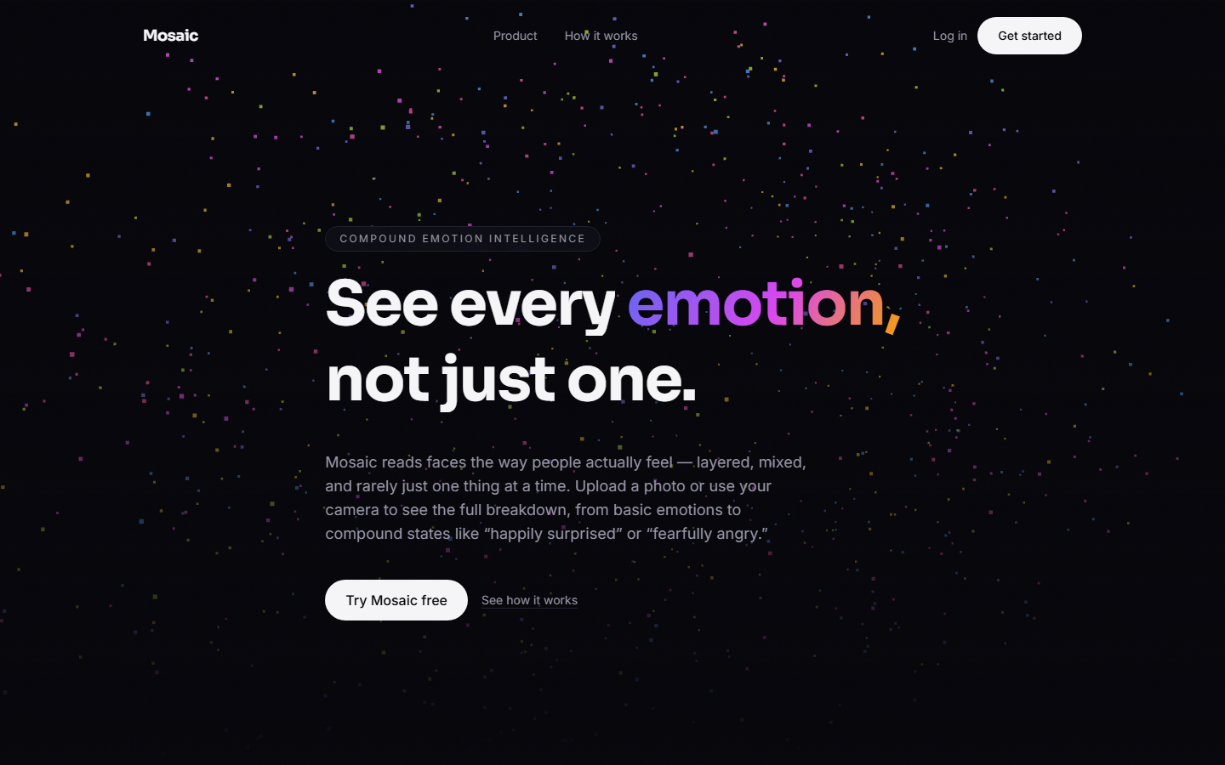
Figure 12: Landing page: hero with the animated particle canvas and the call to action.
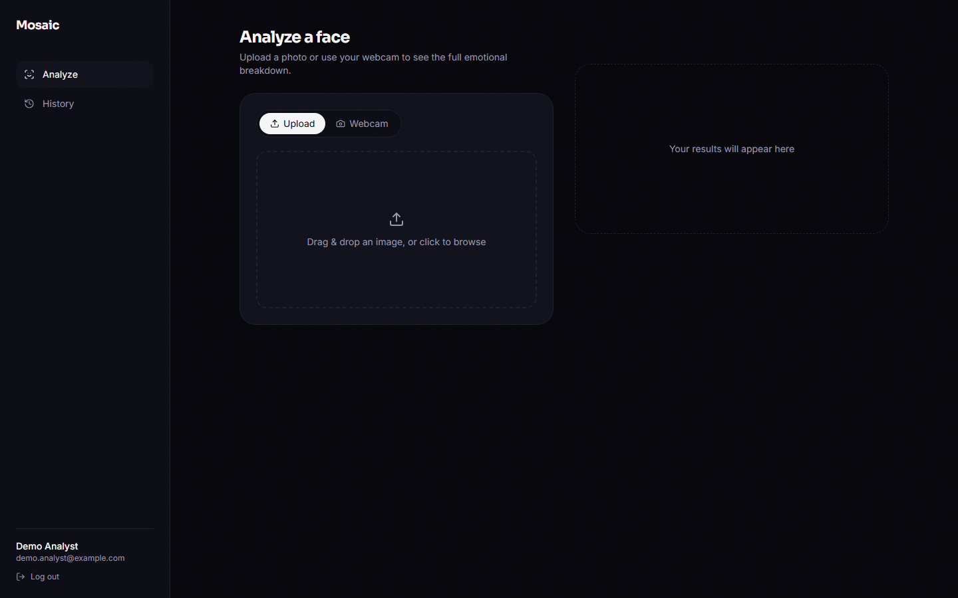
Figure 13: Analyse page before an upload: Upload and Webcam tabs, drop zone and an empty results panel.
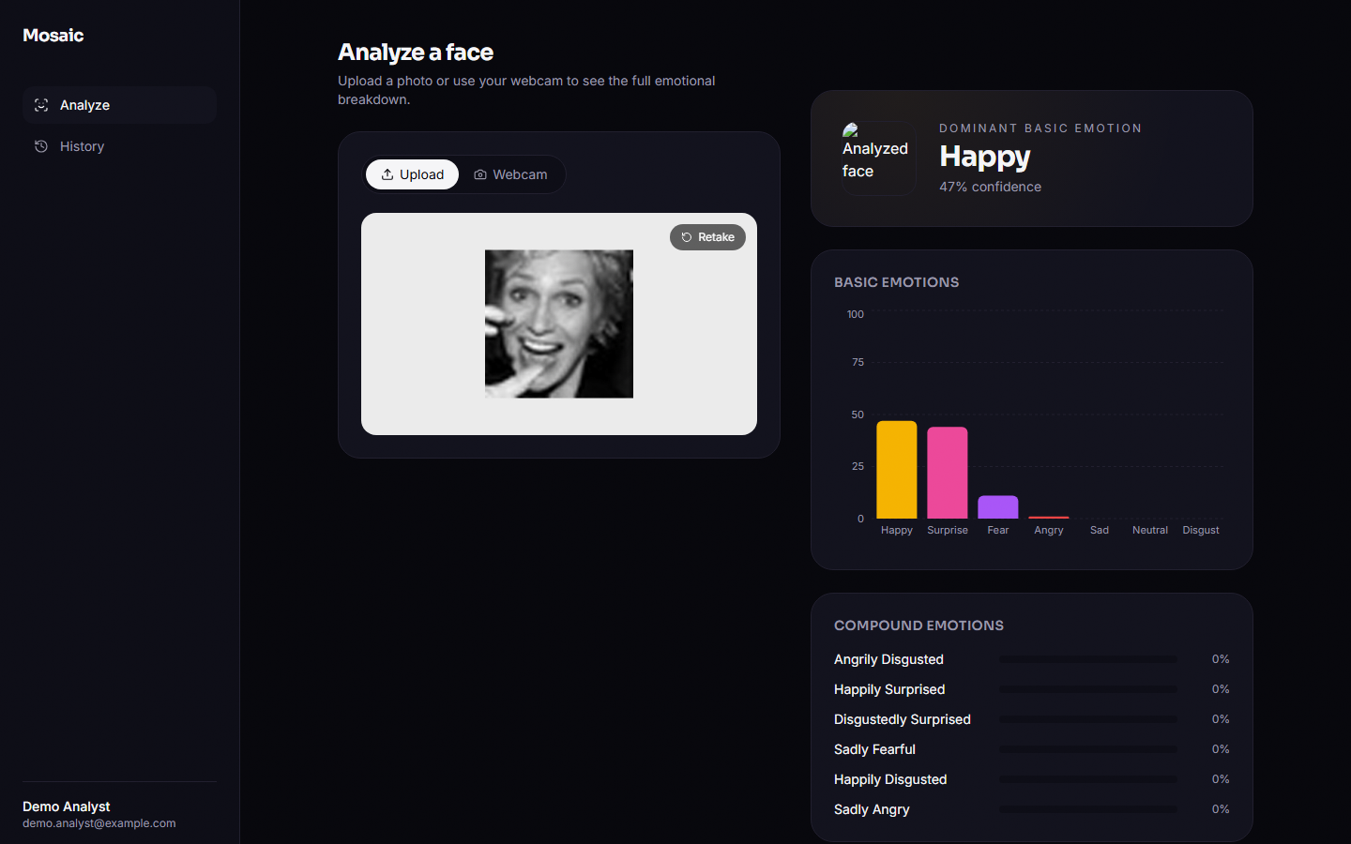
Figure 14: Analyse page after uploading a real FER2013 face: dominant card, basic-emotion chart and compound bars.
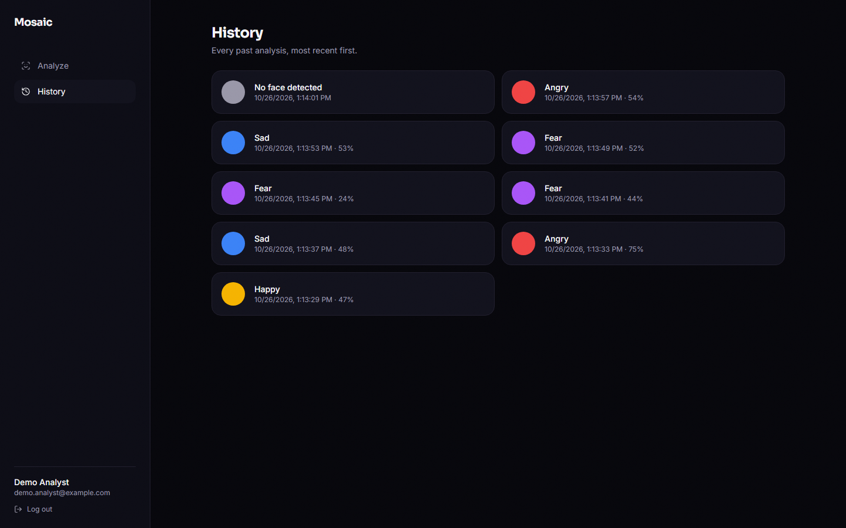
Figure 15: History page: one card per stored analysis with its dominant label, confidence and time.
The analyse page keeps the capture on the left and the results on the right on wide screens (two columns from 1024 px), and stacks them on narrow ones; the sidebar is hidden below 640 px and replaced by a header with a log-out link. The results panel animates in with Framer Motion; compound bars show only the six highest of the eleven scores. Loading, error and empty states each have their own panel.

1.11.1 Interface defects found during design review
• Thumbnail not shown. ResultsView renders result.thumbnail_url directly, a relative path that resolves against the front-end origin instead of the API origin, so the face thumbnail appears as a broken image in every result card. The helper thumbnailUrl() in lib/api.ts would fix it but is not applied there.
• History detail unreachable. /app/history/[id] renders a saved result, but the history cards do not link to it.
• Reload in development mode. In the Next.js development server a hard reload of /app redirected to /login even with a stored token, because the guard runs before the persisted store is read; the production build kept the session in the probe that was run. The screenshots were therefore taken with the production build and in-app navigation.

1.12 Design Decisions and Their Reasons
Table 8: Principal design decisions
Decision | Reason | Cost
One multi-label network with 18 sigmoid outputs | A face can carry several emotions; sigmoid outputs do not compete | No single normalised distribution; thresholds must be chosen
Initialise the final network from a softmax backbone | Faster convergence, and a separately measurable single-label baseline | The comparison with the baseline mixes extra epochs with multi-label training; a real-only control was added in Chapter 8
Condition the generator with a seven-element soft vector | Allows blended conditions such as 0.5 happy + 0.5 surprise without retraining | The generator was trained only on one-hot conditions, so blends are out of distribution
64 x 64 grayscale input | Fits CPU training and the 48 x 48 source data | Loses colour and fine detail
JSON columns for scores | One query per history read; flexible labels | No SQL filtering by score
Optional authentication on /api/analyze | Lets clients try the model without an account | Anonymous calls are not stored; the web UI does not use this path
Haar cascade for detection | Ships with OpenCV; no extra model | Misses non-frontal and very small faces; crops differ from training frames

2. IMPLEMENTATION

2.1 Application Architecture
Mosaic is a two-process application: a FastAPI service [30] that wraps the models, and a Next.js console [31] that talks to it. They share nothing but the HTTP contract in API_CONTRACT.md. The service holds one loaded model in memory (loaded at start-up by load_model() and kept in a module-level variable) and keeps accounts and history in a SQLite file. No external service is called at run time.
Figure 16: Application architecture of Mosaic: browser, FastAPI service, ML modules and local files.
Table 9: Backend modules
File | Responsibility
app/main.py | creates the application, CORS middleware, mounts /api/media/thumbs, includes the four routers, loads the model on start-up (a missing checkpoint is tolerated)
app/config.py | secret key (environment variable MOSAIC_SECRET_KEY, otherwise a development default), HS256, token lifetime (7 days), SQLite URL, checkpoint and thumbnail folders, CORS origins
app/db.py, app/models.py | SQLAlchemy engine, session dependency, User and Analysis tables
app/security.py, app/deps.py | bcrypt hashing and verification, token creation and decoding, required and optional current-user dependencies
app/schemas.py | pydantic request and response models (password at least six characters)
app/routers/auth.py | register, login, me
app/routers/analyze.py | image upload, inference call, optional persistence and thumbnail
app/routers/history.py | paged list, single item, delete, all restricted to the owner
app/routers/health.py | status and whether the model is loaded
app/ml/* | taxonomy, face detection, preprocessing, CNN, GAN, dataset loading, training scripts, inference

The console is a Next.js 16 application written in TypeScript with Tailwind CSS. lib/api.ts wraps fetch and adds the Bearer token; lib/store.ts keeps the token and user in a persisted zustand store (mosaic-auth in local storage); lib/taxonomy.ts and lib/emotionColors.ts mirror the label set. The landing page uses a Three.js canvas, GSAP and Lenis smooth scrolling; the product screens are /app (upload or webcam capture and the result), /app/history and /app/history/[id]. ResultsView draws the dominant card, a Recharts bar chart of the seven basic scores and horizontal bars for the six highest compound scores; the backend still returns all eleven.

2.2 API Design
The API is JSON over HTTP with one multipart endpoint. All paths start with /api. The contract fixes the 18 label keys, so the console never reformats snake_case itself: every item carries key, a display label and a confidence between 0 and 1.
Table 10: Endpoints
Method and path | Auth | Request | Success | Errors
POST /api/auth/register | no | JSON name, email, password | 201 token + user | 409 e-mail exists; 422 short password
POST /api/auth/login | no | JSON email, password | 200 token + user | 401 invalid credentials
GET /api/auth/me | required | - | 200 user | 401
POST /api/analyze | optional | multipart field image | 200 analysis (stored when signed in) | 422 missing field; 500 undecodable file
GET /api/history | required | limit, offset | 200 items + total | 401; 422 non-numeric
GET /api/history/{id} | required | - | 200 analysis | 401; 404 not found or not owned
DELETE /api/history/{id} | required | - | 204 | 401; 404
GET /api/health | no | - | 200 status, model_loaded | -

Real responses captured from the running service follow. Registration returns the user and a signed token (shortened here):
POST /api/auth/register {"name":"Doc Sample","email":"ch6_87424a@example.com","password":"sample-pass-1"}
201 {"token":"eyJhbGciOiJIUzI1NiIsInR5cCI6Ik...",
"user":{"id":"12775519-0a87-4d43-9550-88957a261c21","name":"Doc Sample",
"email":"ch6_87424a@example.com","created_at":"2026-10-26T13:45:36.734980"}}

Analysing a face with a Bearer token returns all seven basic and eleven compound scores sorted by confidence (only the top three of each list are shown), the dominant emotion and the thumbnail path; the row is stored and the cropped face is written to media/thumbs:
POST /api/analyze (multipart image=happy_01.jpg, Authorization: Bearer ...)
200 {"id":"698f315f-dedd-498b-922d-1492cb523479","created_at":"2026-10-26T13:45:36.767207","face_detected":true,
"basic_emotions":[{"key":"happy","label":"Happy","confidence":0.4733},
{"key":"surprise","label":"Surprise","confidence":0.4379},
{"key":"fear","label":"Fear","confidence":0.1133}, ... 4 more],
"compound_emotions":[{"key":"angrily_disgusted","label":"Angrily Disgusted","confidence":1.9e-05},
{"key":"happily_surprised","label":"Happily Surprised","confidence":1.6e-05}, ... 9 more],
"dominant":{"key":"happy","label":"Happy","confidence":0.4733,"kind":"basic"},
"thumbnail_url":"/api/media/thumbs/698f315f-dedd-498b-922d-1492cb523479.jpg"}

The compound confidences in this real response, of the order of 10⁻⁵, are typical of real faces and are discussed in Chapter 8. When no face is found the service still answers 200:
API_CONTRACT.md says that a missing face should return 422; the implementation returns 200 with face_detected false, and the console handles it by showing the message No face was detected in that image. Errors otherwise use FastAPI's standard {"detail": ...} body, for example 401 {"detail":"Not authenticated"} and 409 {"detail":"Email already registered"}.

2.3 Security and Error Handling
Table 11: Security measures and what they do not cover
Area | Implementation | Gap or caveat
Passwords | bcrypt through passlib; minimum six characters | no complexity rule; bcrypt must stay at 4.0.1 (version 5 breaks passlib)
Sessions | HS256 JWT with sub and exp, 7-day lifetime; tampered, expired and foreign-key tokens are rejected as 401 | no refresh or revocation; the token lives in browser local storage
Signing key | read from MOSAIC_SECRET_KEY | a development default is used when the variable is unset and must be replaced in any deployment
Authorisation | history queries filter on user_id; another user's id gives 404 | -
Optional auth | /api/analyze works without a token and then stores nothing | unauthenticated users can consume CPU; no rate limit
SQL injection | all queries go through the SQLAlchemy ORM with bound parameters | -
CORS | only http://localhost:3000 and http://127.0.0.1:3000 are admitted | the list is hard-coded in config.py
Uploads | bytes are decoded in memory; the original photo is never written to disk | no size limit and no content-type check
E-mail | stored as a plain string | not validated: a value such as not-an-email-ab12 is accepted
Transport | plain HTTP in development | no TLS configuration is provided

Error handling is minimal and is described here exactly as it behaves. A request without a valid token to a protected route returns 401; an unknown route 404; a wrong method 405; a malformed body or a missing field 422. If no face is detected the response is a normal 200 (see above). If the uploaded bytes are not a decodable image (a text file, an empty file or a truncated JPEG), Pillow raises an exception inside analyze_image_bytes() and the request ends in HTTP 500; there is no handler. If the checkpoint file is missing, start-up succeeds, /api/health reports model_loaded: false, and the first request that contains a face raises FileNotFoundError (HTTP 500). The unused threshold parameter of analyze_image_bytes() has no effect.

2.4 Installation and Execution
The code defaults are port 8000 for the API and port 3000 for the console. The console reads the API address from the build-time variable NEXT_PUBLIC_API_URL (default http://localhost:8000/api). The backend needs Python 3.10 or newer and the packages of requirements.txt (FastAPI, SQLAlchemy, python-jose, passlib with bcrypt==4.0.1, PyTorch, OpenCV, Pillow, NumPy, pandas); the console needs Node.js and npm install. The sequence is: create a virtual environment, install the requirements, run python -m app.ml.run_pipeline once (the three training stages, about 30 to 60 minutes on a CPU, writing the checkpoints and the training log), start uvicorn app.main:app --port 8000, then npm run dev in frontend/. For the measurements and screenshots in this report port 8000 was in use by another program, so the API ran on port 8116 and the console was a production build (npm run build, npm start) with NEXT_PUBLIC_API_URL set accordingly. The repository contains no run.bat, setup.bat or .env.example; Appendix B lists the steps in full.
Automated checks live in backend/tests: 28 tests, 0 failures (unit tests for the taxonomy, security helpers, network shapes, preprocessing and synthesis labels, and API tests with a temporary database that cover registration, login, analysis, history privacy and two characterised defects). On this machine, over 127.0.0.1, an anonymous analysis of a detected face takes 19 ms (median) and 26 ms (95th percentile), and a login about 219 ms, dominated by bcrypt.

3. KEY CODE WALK-THROUGHS

3.1 The inference function: analyze_image_bytes()
analyze_image_bytes() in app/ml/inference.py is the one function every request passes through. It decodes the upload with Pillow, converts it to BGR for OpenCV, asks the Haar detector for the largest face and returns early with face_detected false when there is none. Otherwise it preprocesses the crop, runs the 18-output network, applies a sigmoid, builds the two sorted lists and chooses the dominant label as the argmax over all 18 probabilities.
def analyze_image_bytes(image_bytes: bytes, threshold: float = 0.0):
"""Returns (face_detected, basic_scores, compound_scores, dominant, face_crop_bgr)."""
pil_img = Image.open(io.BytesIO(image_bytes)).convert("RGB")
rgb = np.array(pil_img)
bgr = cv2.cvtColor(rgb, cv2.COLOR_RGB2BGR)

face_gray = detect_largest_face(bgr)
if face_gray is None:
return False, [], [], None, None

model = load_model()
tensor = _preprocess(face_gray)
with torch.no_grad():
logits = model(tensor)
probs = torch.sigmoid(logits).squeeze(0).numpy()

scores = {label: float(probs[i]) for i, label in enumerate(ALL_LABELS)}

basic_scores = sorted(
[{"key": k, "label": display_label(k), "confidence": scores[k]} for k in BASIC_EMOTIONS],
key=lambda x: x["confidence"],
reverse=True,
)
compound_scores = sorted(
[{"key": k, "label": display_label(k), "confidence": scores[k]} for k in COMPOUND_EMOTIONS],
key=lambda x: x["confidence"],
reverse=True,
)

best_key = max(scores, key=scores.get)
kind = "basic" if best_key in BASIC_EMOTIONS else "compound"
dominant = {"key": best_key, "label": display_label(best_key), "confidence": scores[best_key], "kind": kind}

return True, basic_scores, compound_scores, dominant, face_gray

Three details matter. The threshold argument is accepted but never used. The dominant label is the maximum over basic and compound outputs together, so with near-zero compound probabilities it is always a basic emotion. A non-image upload raises inside Pillow and is not caught, which is why the API answers HTTP 500 for such files.

3.2 The router: persistence and thumbnail
routers/analyze.py reads the multipart file, calls the inference function and, when a valid token is present, inserts an Analysis row, writes the cropped face to media/thumbs/<id>.jpg and stores the path. Anonymous callers receive the same body with id null.
async def analyze(
image: UploadFile = File(...),
user: User | None = Depends(get_current_user_optional),
db: Session = Depends(get_db),
):
image_bytes = await image.read()
face_detected, basic, compound, dominant, face_gray = analyze_image_bytes(image_bytes)

if user is None:
from datetime import datetime, timezone

return AnalysisResponse(
id=None,
created_at=datetime.now(timezone.utc),
face_detected=face_detected,
basic_emotions=basic,
compound_emotions=compound,
dominant=dominant,
thumbnail_url=None,
)

record = Analysis(
user_id=user.id,
face_detected=face_detected,
basic_emotions=basic,
compound_emotions=compound,
dominant=dominant,
)
db.add(record)
db.commit()
db.refresh(record)

if face_detected and face_gray is not None:
thumb_path = MEDIA_DIR / f"{record.id}.jpg"
cv2.imwrite(str(thumb_path), face_gray)
record.thumbnail_path = str(thumb_path)
db.commit()
db.refresh(record)

return analysis_to_response(record)

3.3 Synthesising compound training faces
synthesize() builds, for each of the eleven compound classes, a condition vector with 0.5 on each of the two component emotions, samples Gaussian noise, runs the generator and writes a three-bit target (both basics and the compound). The generator itself was trained only on one-hot conditions, so the blended condition is an extrapolation.
def synthesize(generator: ConditionalGenerator, n_per_class: int = 200):
"""Returns (images uint8 [N,64,64], multihot_labels float32 [N, NUM_LABELS])."""
all_images = []
all_labels = []
for compound_key in COMPOUND_EMOTIONS:
a, b = COMPOUND_COMPONENTS[compound_key]
cond = torch.zeros(n_per_class, NUM_BASIC)
cond[:, BASIC_INDEX[a]] = 0.5
cond[:, BASIC_INDEX[b]] = 0.5
z = torch.randn(n_per_class, NOISE_DIM)
imgs = generator(z, cond) # [-1, 1], N x 1 x 64 x 64
imgs_uint8 = ((imgs.squeeze(1).numpy() * 0.5 + 0.5) * 255.0).clip(0, 255).astype(np.uint8)

label_vec = np.zeros(NUM_LABELS, dtype=np.float32)
label_vec[LABEL_INDEX[a]] = 1.0
label_vec[LABEL_INDEX[b]] = 1.0
label_vec[LABEL_INDEX[compound_key]] = 1.0
labels = np.tile(label_vec, (n_per_class, 1))

all_images.append(imgs_uint8)
all_labels.append(labels)

return np.concatenate(all_images, axis=0), np.concatenate(all_labels, axis=0)

3.4 Training the final classifier
The final stage copies the backbone's convolutional weights into an 18-output network, then trains on real faces (one basic bit each) and synthetic faces with binary cross-entropy on the logits. The compound bits are positive only for the 2,200 synthetic rows, about 7.1 % of the data, which is why the compound outputs settle near zero for real faces.
criterion = nn.BCEWithLogitsLoss()
optimizer = torch.optim.Adam(model.parameters(), lr=lr)

for epoch in range(1, epochs + 1):
t0 = time.time()
model.train()
total_loss = 0.0
for xb, yb in train_loader:
optimizer.zero_grad()
out = model(xb)
loss = criterion(out, yb)
loss.backward()
optimizer.step()
total_loss += loss.item() * xb.size(0)
train_loss = total_loss / len(train_ds)

3.5 Tokens and the optional-user dependency
Passwords are hashed with bcrypt through passlib; access tokens are HS256 JWTs with a seven-day expiry and the user id as subject. The dependency get_current_user_optional returns None for a missing or invalid token, which is how /api/analyze serves anonymous callers, while get_current_user raises 401.
def create_access_token(subject: str) -> str:
expire = datetime.now(timezone.utc) + timedelta(minutes=ACCESS_TOKEN_EXPIRE_MINUTES)
payload = {"sub": subject, "exp": expire}
return jwt.encode(payload, SECRET_KEY, algorithm=ALGORITHM)

def decode_access_token(token: str) -> str | None:
try:
payload = jwt.decode(token, SECRET_KEY, algorithms=[ALGORITHM])
return payload.get("sub")
except JWTError:
return None

def _resolve_user(creds: Optional[HTTPAuthorizationCredentials], db: Session) -> Optional[User]:
if creds is None:
return None
user_id = decode_access_token(creds.credentials)
if user_id is None:
return None
return db.query(User).filter(User.id == user_id).first()

4. IMPLEMENTATION DECISIONS AND THEIR REASONS
Each decision is given with the reason it was taken and what the measurements say about it.

4.1 Haar cascade instead of a deep face detector
The Haar cascade ships with OpenCV, needs no extra weights and runs in a few milliseconds on a CPU [23], [29]. The price is recall: it finds none of the native 48-pixel FER faces and 56.5 % after a threefold upscale, and the crop differs from the training framing. A modern detector with landmark alignment would be the first upgrade.

4.2 64x64 grayscale input
FER2013 faces are 48x48 grayscale. Resizing to 64 gives the four pooling stages an integer 4x4 map at the end and keeps the network small (770,130 parameters at 18 outputs). Colour and higher resolution were not tried because the training data has neither.

4.3 Sigmoid outputs with binary cross-entropy
Complex emotions co-occur with their components, so each of the 18 labels is an independent Bernoulli variable, as in the base paper [1] and in multi-label learning generally [27]. A softmax would force a single winner. The cost is that probabilities are not normalised and, with 2,200 compound-positive rows out of 30,909, the compound outputs are strongly shrunk toward zero.

4.4 A 0.5 / 0.5 condition for compound synthesis
The generator takes a seven-dimensional condition. For a compound class the two component entries are set to 0.5, which keeps the vector's sum equal to the one-hot training value. The base paper activates two bits of a six-dimensional label [1]. Here the generator was never trained on such mixtures and the stage-1 classifier recovers the requested pair only 8.3 % of the time, so the decision did not produce usable compound faces.

4.5 Initialising the final network from the backbone
Transfer from the 7-class backbone gives the final network a head start on basic emotions. It also means the final model has had ten epochs in total, against five for the baseline, which is why the real-only control (same initialisation, no synthetic images) was needed to judge the GAN.

4.6 Argmax over all 18 outputs for the dominant label
The rule is simple and always yields one label, but it presumes compound probabilities are on the same scale as basic ones. With a maximum of about 0.00019 on real faces they never win. Per-label thresholds calibrated on real compound data would be needed.

4.7 SQLite with JSON columns for history
One file, no server, and one row per analysis keeps a history read to a single query: listing 20 items takes a median of 6.6 ms. The trade-off is that emotion lists cannot be queried relationally.

4.8 Optional authentication for analysis
Anyone can call /api/analyze; a valid token merely adds persistence. This keeps the demo friction-free but means the endpoint has no rate limit and no ownership check beyond the optional user.

4.9 CPU-only training and inference
The target machine has no GPU. The CNN has 770,130 parameters and a request takes 19.3 ms at the median, so a CPU is enough for serving; training took about two minutes per epoch while other jobs shared the processor, which is why training budgets are small.

4.10 A Next.js client with a persisted token
The console keeps the token in a persisted zustand store and sends it as a Bearer header. The guard runs before the store is read on a hard reload in development mode, which sends the user back to the login page; in the production build the session survived a reload in the probe run.

